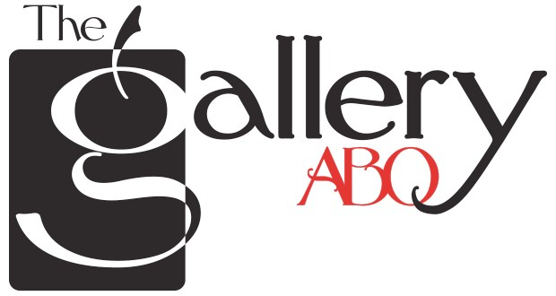

8210 Menaul Blvd., NE, Albuquerque, NM 87110 | (505) 292-9333

APPLICATION FOR MEMBERSHIP

(Please Type or Print all information clearly)

Name _____________________________________________________________________________
Physical Address ____________________________________________________________________
Mailing Address _____________________________________________________________________
Employment ________________________________________________________________________
Home Phone ___________________________ Work Phone _________________________________
E-Mail Address ______________________________________________________________________

List media in which you work and prioritize what you wish to exhibit ________________________
___________________________________________________________________________________ ___________________________________________________________________________________

Price range of your work at present ____________________________________________________

Who referred you to us? ______________________________________________________________

Current or recent affiliations with galleries, museums, shows, art organizations, publications, etc.
(Please list no more than five and be specific as possible.)
___________________________________________________________________________________
___________________________________________________________________________________
___________________________________________________________________________________
___________________________________________________________________________________
___________________________________________________________________________________ ___________________________________________________________________________________
Experience with art galleries or business ventures? (Please explain) _________________________
___________________________________________________________________________________
___________________________________________________________________________________
___________________________________________________________________________________ ___________________________________________________________________________________

Do you have other commitments that would restrict gallery participation? If so, please explain.
(This would not disqualify you from membership. However, members are required to sit the gallery, attend meetings on the second
Monday of the month at the gallery, attend openings, serve on a committee, and help with physical maintenance of the gallery.)
___________________________________________________________________________________
___________________________________________________________________________________ ___________________________________________________________________________________

Please give a short statement about why you’d like to be a member _________________________
___________________________________________________________________________________
___________________________________________________________________________________
___________________________________________________________________________________ ___________________________________________________________________________________

Please list Two References: Name and contact information.
___________________________________________________________________________________ ___________________________________________________________________________________

A copy of this application should accompany your submissions for jurying. You should submit at least THREE pieces of gallery-ready artwork in each medium you wish to exhibit. We would like you to be present at the beginning of our meeting to present your work. Every precaution will be taken to ensure the safety of your artwork. The Gallery ABQ cannot be responsible for loss or damage to your work.
If accepted, you agree to sign the one-year commitment form included with the membership information.
Please sign below to confirm your understanding of this agreement.
SIGNATURE _________________________________________ DATE __________________
For more information, please call: Patricia Cream C 505-321-4232 Updated Jan 9.2020

